**DAY 4**

**CLASS EX:1**

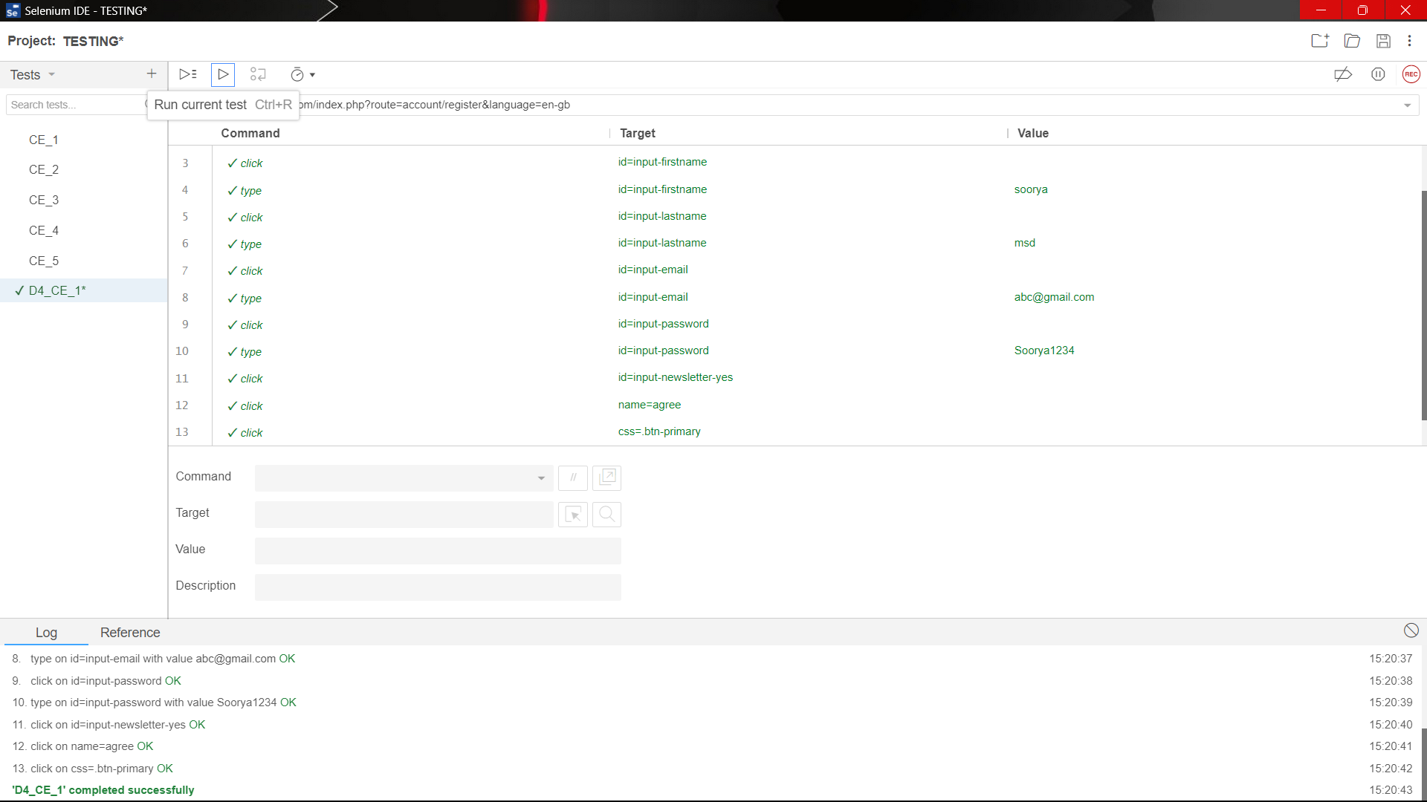

**CLASS EX:2**

package com.Test.Testing;

import org.openqa.selenium.By;

import org.openqa.selenium.WebDriver;

import org.openqa.selenium.WebElement;

import org.openqa.selenium.chrome.ChromeDriver;

import org.openqa.selenium.chrome.ChromeOptions;

import io.github.bonigarcia.wdm.WebDriverManager;

public class Dayfour2 {

public static void main(String[] args) throws InterruptedException

{

ChromeOptions co=new ChromeOptions();

co.addArguments("--remote-allow-origins=*");

WebDriverManager.chromedriver().setup();

WebDriver driver =new ChromeDriver(co);

driver.get("https://demo.opencart.com/index.php?route=account/register&language=en-gb");

Thread.sleep(5000);

WebElement el= driver.findElement(By.name("firstname"));

el.sendKeys("Soorya");

WebElement el2= driver.findElement(By.name("lastname"));

el2.sendKeys("T");

WebElement el3= driver.findElement(By.name("email"));

el3.sendKeys("727721euit153@skcet.ac.in");

WebElement el4= driver.findElement(By.name("password"));

el4.sendKeys("Sooryamsd");

WebElement el5= driver.findElement(By.name("agree"));

el5.click();

WebElement el6= driver.findElement(By.xpath("//*[@id=\"form-register\"]/div/div/button"));

el6.click();

// bt.click();

// TODO Auto-generated method stub

}

}

**CLASS EX:3**

package com.Test.Testing;

import org.openqa.selenium.By;

import org.openqa.selenium.JavascriptExecutor;

import org.openqa.selenium.WebDriver;

import org.openqa.selenium.chrome.ChromeDriver;

import org.openqa.selenium.chrome.ChromeOptions;

import io.github.bonigarcia.wdm.WebDriverManager;

public class Dayfour {

public static void main(String args[] )throws InterruptedException{

ChromeOptions co=new ChromeOptions();

co.addArguments("--remote-allow-origins=*");

WebDriverManager.chromedriver().setup();

WebDriver driver=new ChromeDriver();

driver.get("https://demo.opencart.com/index.php?route=checkout/voucher&language=en-gb");

driver.manage().window().maximize();

driver.findElement(By.xpath("//input[@id=\"input-to-name\"]")).sendKeys("Pavithra");

JavascriptExecutor js=(JavascriptExecutor) driver;

js.executeScript("window.scrollBy(0,500)", "");

Thread.sleep(5000);

driver.findElement(By.xpath("//input[@id=\"input-theme-6\"]")).click();

driver.findElement(By.xpath("//input[@id=\"input-theme-6\"]")).click();

driver.findElement(By.xpath("//*[@id=\"form-voucher\"]/div[8]/div/div/input")).click();

driver.findElement(By.xpath("//*[@id=\"form-voucher\"]/div[8]/div/button")).click();

}

}

**CLASS EX:4**

package com.Test.Testing;

import org.openqa.selenium.By;

import org.openqa.selenium.WebDriver;

import org.openqa.selenium.WebElement;

import org.openqa.selenium.chrome.ChromeDriver;

import org.openqa.selenium.chrome.ChromeOptions;

import io.github.bonigarcia.wdm.WebDriverManager;

public class Dayfour4 {

public static void main(String[] args)throws InterruptedException {

// TODO Auto-generated method stub

ChromeOptions co=new ChromeOptions();

co.addArguments("--remote-allow-origins=*");

WebDriverManager.chromedriver().setup();

WebDriver driver =new ChromeDriver(co);

driver.get("https://j2store.net/free/");

Thread.sleep(5000);

WebElement el6= driver.findElement(By.xpath("//*[@id=\"Mod112\"]/div/div/ul/li[1]/a"));

el6.click();

driver. navigate(). back();

driver. navigate(). forward();

driver. navigate().refresh();

}

}

**OUTPUT:**

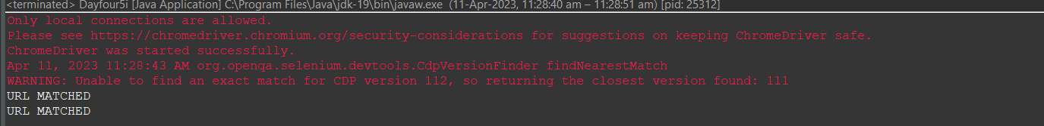

**CLASS EX:5(i)**

package com.Test.Testing;

import org.openqa.selenium.By;

import org.openqa.selenium.WebDriver;

import org.openqa.selenium.WebElement;

import org.openqa.selenium.chrome.ChromeDriver;

import org.openqa.selenium.chrome.ChromeOptions;

import io.github.bonigarcia.wdm.WebDriverManager;

public class Dayfour5i {

public static void main(String []Args) {

ChromeOptions co=new ChromeOptions();

co.addArguments("--remote-allow-origins=*");

WebDriverManager.chromedriver().setup();

WebDriver driver =new ChromeDriver(co);

driver.get("https://j2store.net/free/");

String cUrl=driver.getCurrentUrl();

if(cUrl.equals("https://j2store.net/free/")) {

System.out.println("URL MATCHED");

}

else {

System.out.println("URL NOT MATCHED");

}

WebElement el6= driver.findElement(By.linkText("Clothing (5)"));

el6.click();

String cUrl1=driver.getCurrentUrl();

if(cUrl1.equals("https://j2store.net/free/index.php/shop?filter_catid=11")) {

System.out.println("URL MATCHED");

}

else {

System.out.println("URL NOT MATCHED");

}

}

}

**CLASS EX:5(iI)**

package com.Test.Testing;

import org.openqa.selenium.By;

import org.openqa.selenium.WebDriver;

import org.openqa.selenium.WebElement;

import org.openqa.selenium.chrome.ChromeDriver;

import org.openqa.selenium.chrome.ChromeOptions;

import java.util.*;

import io.github.bonigarcia.wdm.WebDriverManager;

public class Dayfour5ii {

public static void main(String []Args) {

ChromeOptions co=new ChromeOptions();

co.addArguments("--remote-allow-origins=*");

WebDriverManager.chromedriver().setup();

WebDriver driver =new ChromeDriver(co);

driver.get("https://j2store.net/free/");

WebElement el6= driver.findElement(By.linkText("Clothing (5)"));

el6.click();

List<WebElement> li=driver.findElements(By.xpath("//h2[@itemprop=\"name\"]"));

for(WebElement e:li) {

System.out.println(e.getText());

}

}

}

**OUTPUT:**

